Low-temperature behaviour of TiO₂

Ivanna SHEVCHENKO^{1,2}*, John B. SMITH³

¹ Department of Inorganic Chemistry, Ivan Franko National University of Lviv,
Kyryla i Mefodiya St. 6, 79005 Lviv, Ukraine
² Department of Condensed Matter Physics, Faculty of Mathematics and Physics, Charles University,
Ke Karlovu 5, 121 16 Prague 2, Czech Republic
³ Laboratory of Crystallography, University of Geneva,
24 Quai Ernest-Ansermet, CH-1211 Geneva 4, Switzerland
* Corresponding author. Tel.: +380-32-1234567; e-mail: author@lnu.edu.ua

Abstract

Keywords

Introduction

Experimental

Results and discussion

Acknowledgements

References

[1] N. Muts, R. Gladyshevskii, E. Gladyshevskii, J. Alloys Compd. 402 (2005) 66-69.
https://doi.org/10.1016/j.jallcom.2004.11.097
[2] Y. Fukai, The Metal-Hydrogen Systems: Basic Bulk Properties, Springer-Verlag, Berlin, 1993, 355 p.
[3] B.R. Cooper, R. Sieman, D. Yang, P. Thayamballi, A. Banerjea, In: A.A. Freeman, G.H. Lander (Eds.), Handbook on the Physics and Chemistry of the Actinides, Vol. 2, Elsevier, Amsterdam, 1985, pp. 435-500.
[4] Yu. Lutsyshyn, Coll. Abstr. IX Int. Conf. Cryst. Chem. Intermet. Compd., Lviv, 2005, p. 153.
[5] E. Bellingeri, Thesis, University of Geneva, 2000.
[6] D.B. Wiles, A. Sakthivel, R.A. Young, Program DBWS3.2 for Rietveld Analysis of X-Ray and Neutron Powder Diffraction Patterns, School of Physics, Georgia Institute of Technology, Atlanta, 1998.

Tables

Table 1 xxxxxxxxxxxxxxxxxxxxxxxxxxxxx.

Table 2 xxxxxxxxxxxxxxxxxxxxxxxxxxxxx.

Figures

Fig. 1 (a) xxxxxxxxxxxxxxxxxxxxxxxxx.

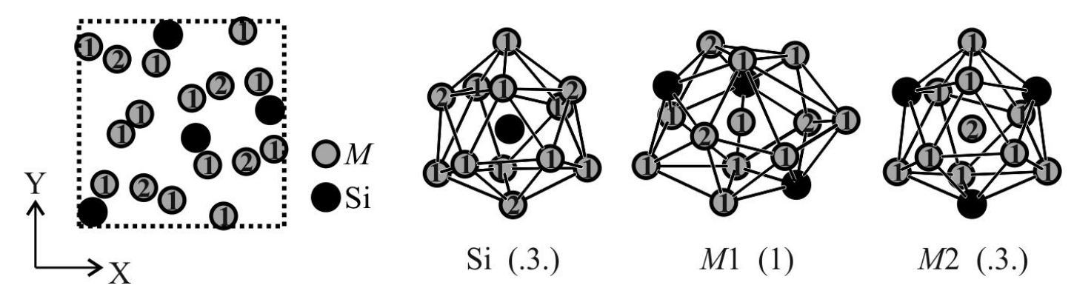

Fig. 2 xxxxxxxxxxxxxxxxxxxxxxxxx.

Figure for on-line abstract

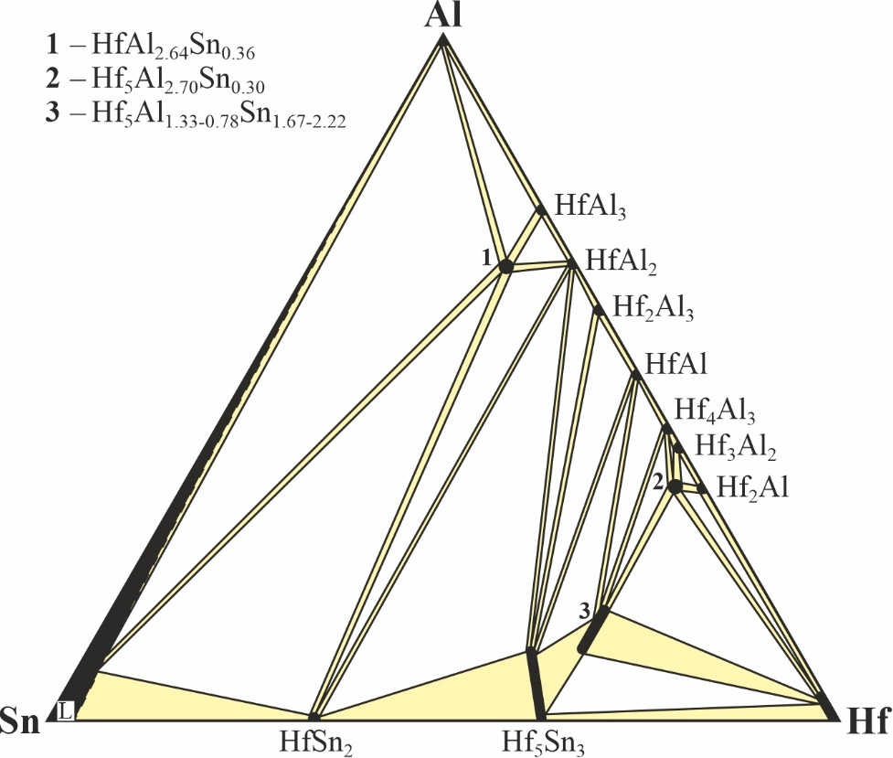

xxxxxxxxxxxxxxxxxxxxxxxxx.

